Phase 2: Milestones 1 & 2 Execution
Create New Service and Create New Service Offering
Date | 21-10-2026
Team ID | Individual participant - 324103312L29@gvpce.ac.in
Project Name | Incident Lifecycle Automation in ServiceNow
Maximum Marks | As specified by template

1. Task Overview & Executive Summary
• Objective: Establish the foundational CMDB service architecture by creating a main Business/Technical Service and attaching a specific Service Offering, so incidents can be classified and routed accurately.
• Milestone 1: Create New Service (CMDB Service Configuration), table cmdb_ci_service.
• Milestone 2: Create New Service Offering, table service_offering.

2. Step-by-Step Implementation Details
Milestone 1: Create New Service (Target Table: cmdb_ci_service)
Step | Action performed | Detail
1 | Navigated to the All application menu in ServiceNow. | All menu in the top navigation bar.
2 | Entered cmdb_ci_service.LIST in the Application Navigator. | cmdb_ci_service.LIST
3 | Clicked New to initialize a new Service record. | New button on the service list.
4 | Configured the record parameters. | Name: Remote Access; Operational Status: Operational.
5 | Submitted the form to register the service in CMDB. | Submit on the form.
Milestone 2: Create New Service Offering (Target Table: service_offering)
Step | Action performed | Detail
1 | Navigated to the All application menu in ServiceNow. | All menu in the top navigation bar.
2 | Entered service_offering.LIST in the Application Navigator. | service_offering.LIST
3 | Clicked New to initialize a new Service Offering record. | New button on the offering list.
4 | Configured the record parameters. | Name: Corporate VPN; Parent: Remote Access; Operational Status: Operational.
5 | Submitted the form to link the offering to its parent service. | Submit on the form.

3. Business Value & Incident Management Impact
Setting up Remote Access as the parent service and Corporate VPN as its specific offering gives Service Operations Workspace structured data to work with.
• Triage accuracy: agents pick the exact service and offering on the incident, so VPN issues are classified correctly from the start.
• Root-cause tracking: incidents are grouped under Remote Access and Corporate VPN, so repeated problems are easy to spot.
• SLA reporting: service and offering mapping lets SLAs apply to the right incidents and be reported by service.

4. Combined Verification Matrix
Milestone ID | Configuration Task | Target Table / Navigation | Key Parameters | Status
M1 | Create new service | cmdb_ci_service (All > cmdb_ci_service.LIST > New) | Name: Remote Access | Pass
M1 | Set operational status | cmdb_ci_service | Operational Status: Operational | Pass
M1 | Register service in CMDB | cmdb_ci_service | Remote Access saved | Pass
M2 | Create new service offering | service_offering (All > service_offering.LIST > New) | Name: Corporate VPN | Pass
M2 | Link offering to parent service | service_offering | Parent: Remote Access | Pass
M2 | Set operational status | service_offering | Operational Status: Operational | Pass
M2 | Register offering in CMDB | service_offering | Corporate VPN saved under Remote Access | Pass

5. Configuration Evidence
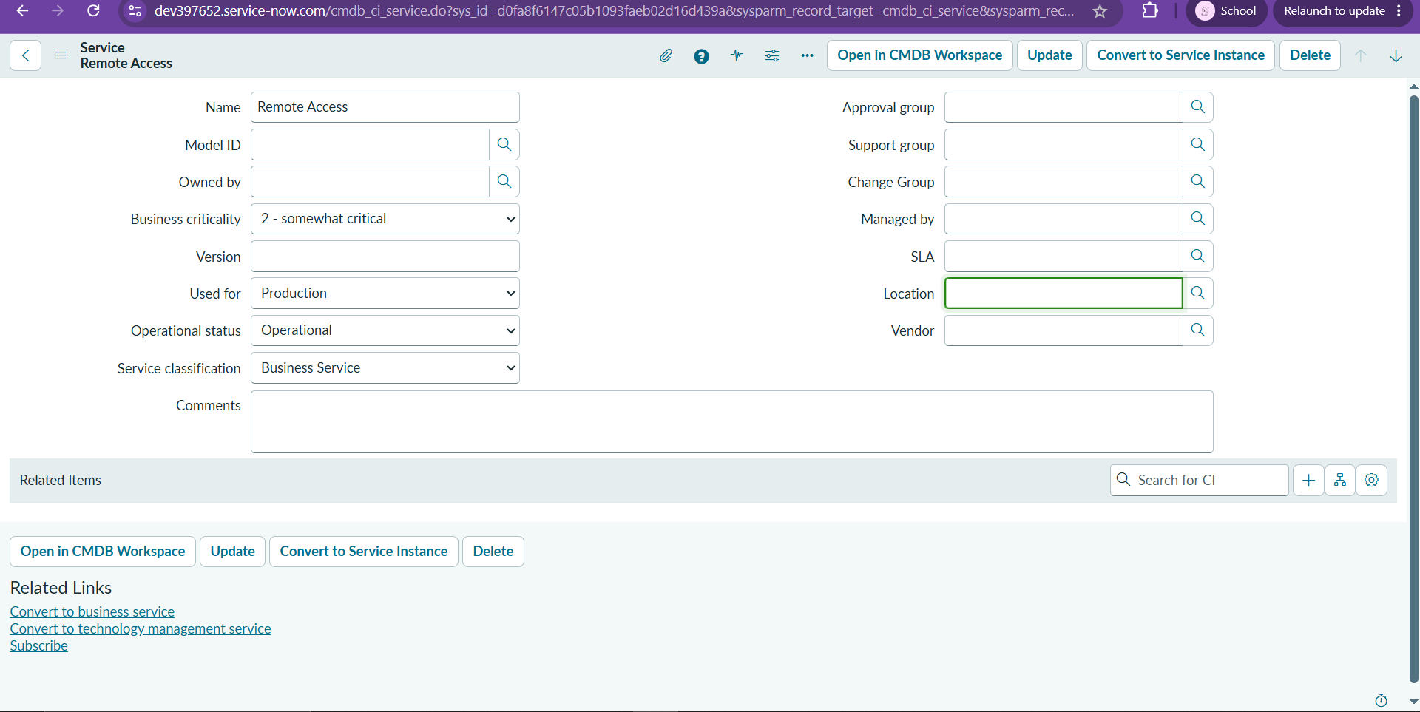
Milestone 1: service record Remote Access in cmdb_ci_service (Operational).
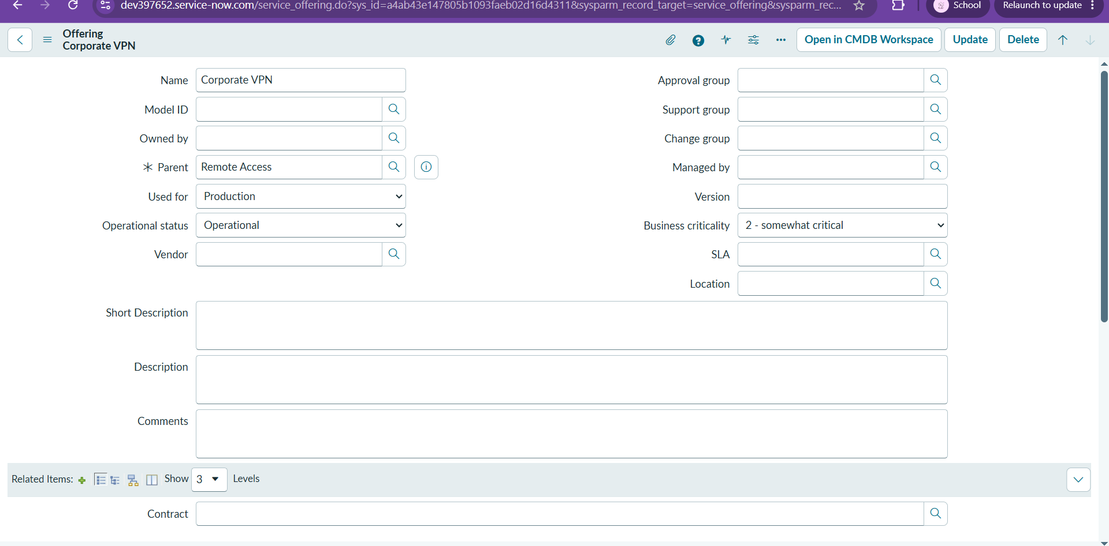
Milestone 2: service offering Corporate VPN with parent Remote Access (Operational).

